**ACTIVITY 10**

**NAME : Abinaya COURSE: MOBILE COMPUTING**

**REG NO : 192421208 COURSE CODE: ITA0302**

10. Create a visual representation in Figma showcasing the differences between various

multiple access techniques.

**Aim:** To create a visual representation in Figma showcasing the differences between various

multiple access techniques.

**Procedure:**

1. Open Figma

2. Create a new file

3. Select the Frames

4. Fill in the content that is required for presentation

5. Design Visual Elements

6. Make it Interactive

7. Add Annotations and Explanations

8. Incorporate Multimedia

9. Storyboard Animation

10. Review and edit the Prototype

11. Save and Share

**Design:**

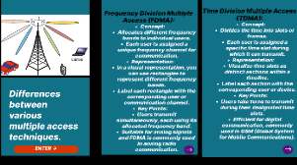

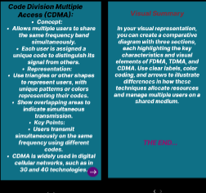

**Prototype:**

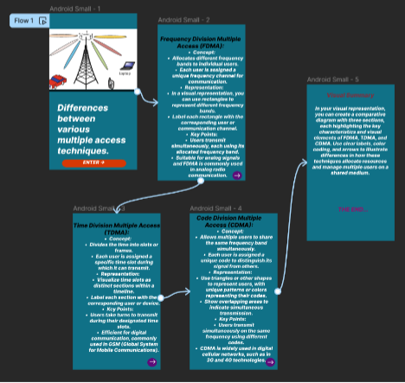

**Result:**

Hence created a visual representation in Figma showcasing the differences between various

multiple access techniques.